# Module 3 Practice Quiz 2

**6/6** points earned (100%)

Excellent!

Retake

[Course Home](https://www.coursera.org/learn/corporate-finance/home/welcome)

Correct

1 / 1 points

1. Suppose I offer you an investment that requires 15,000 today and pays back 17,500 in a year's time. What is the (IRR) rate of return on this investment?

1. **16.67%**

**Correct Response**

The IRR is clearly 2,500/15,000 = 16.67%. You can find the IRR by setting the NPV to zero:

NPV = -15,000 + 17,500/(! + discount rate) = 0

The discount rate that solves this equation is 16.67%. This is the IRR.

1. 10.33%
2. -16.6%
3. 20%

Correct

1 / 1 points

2. An investment requires 25,000 today and produces an yearly cash flow of 1200 in perpetuity. Cash flow is expected to grow at 3% a year. What is the rate of return of this investment?

1. 3%
2. You need the discount rate to solve this problem.
3. 4.8%
4. **7.8%**

**Correct Response**

Now you must set the NPV to zero.

NPV = -25,000 + 1,200/(discount rate - 3%) = 0

Solve this equation to find IRR = 3% + 1,200/25,000 = 7.8%

Correct

1 / 1 points

3. The rate of return on an investment project is 10%. Which of the following statements is incorrect?

1. You need to know the discount rate to make a decision on this project.
2. If the discount rate is 11%, the project's NPV is negative.
3. If the discount rate is 9%, you should take the project.
4. **The discount rate is also equal to 10%**

**Correct Response**

You need to know the discount rate to know whether the NPV is positive or not. If the discount rate is higher (lower) than IRR, the project is negative (positive) NPV. The discount rate is not the same as the IRR, so the wrong option is that the discount rate is also equal to 10%.

Correct

1 / 1 points

4. Which of the following two assets offers a greater rate of return (IRR)?

* -Asset 1 costs 20,000 today and pays 11,000 in one year and 11,000 in two years.
* -Asset 2 is a growing perpetuity that costs 2,000 today, pays a first cash flow of 70 next year, and grows at a 4% rate.

1. Asset 1
2. **Asset 2**

**Correct Response**

For Asset 1 your solve

NPV = -20,000 + 11,000/(1 + discount rate) + 11,000/(1 + discount rate)^2 = 0

You can do this in Excel:

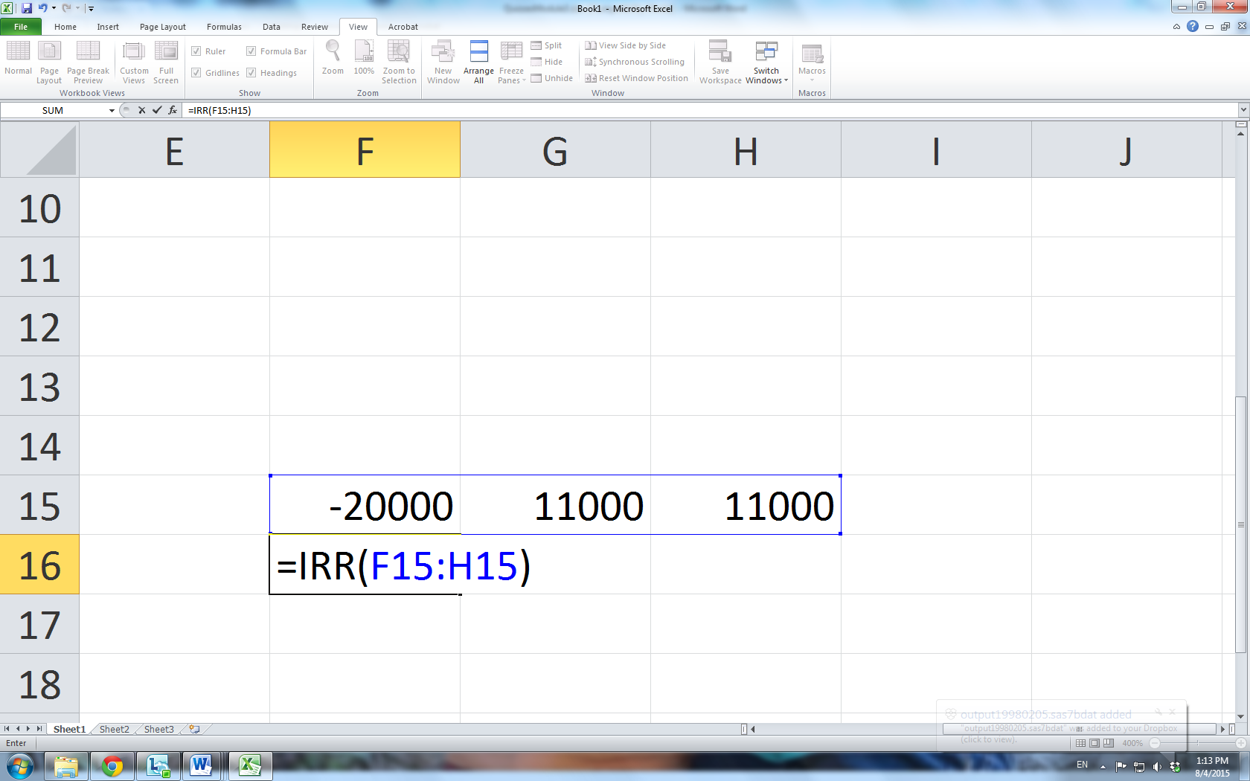

Asset 1's IRR is 6.60%.

To find asset 2.s IRR set the NPV to zero:

NPV = -2,000 + 70/(discount rate - 4%) = 0.

This gives IRR =70/2,000 + 4% = 7.5%.

Thus, Asset 2 has the higher IRR.

1. They both have the same IRR
2. You cannot compute the IRR for Asset 2

Correct

1 / 1 points

5. Consider the data in problem 4. Is the following statement true or false?

Since Asset 2 has the greater IRR, it is a better investment than Asset 1.

1. True
2. **False**

**Correct Response**

Correct

1 / 1 points

6. Consider an investment that requires an outlay of -100 today and returns a yearly cash flow of 75 for 2 years. Then, in the third year you must pay -40 to close down the investment. Which of the following statements is correct?

1. This is obviously a bad investment because there is a negative cash flow at the end of the project’s life.
2. This project's NPV is equal to zero.
3. This project's IRR is equal to 10.1%
4. **You should not compute the IRR for this project since there is a negative cash flow following positive ones.**

**Correct Response**

The correct answer is d. This is a case in which we should not rely on the IRR. Excel will give you an IRR of 10.1%, but you can check that -54.8% is another possible IRR (the NPV is zero at this discount rate).